Ecommerce SQL Challenge

# Database and Tables Creation

CREATE DATABASE ecommerce_db;  
USE ecommerce_db;  
  
  
CREATE TABLE customers (

customer_id INT PRIMARY KEY,

first_name VARCHAR(100),

last_name VARCHAR(100),

email VARCHAR(100),

password VARCHAR(100)

);  
  
CREATE TABLE products (  
 product_id INT PRIMARY KEY,  
 name VARCHAR(100),  
 price DECIMAL(10,2),  
 description VARCHAR(255),  
 stockQuantity INT  
);  
  
  
 CREATE TABLE cart (  
 cart_id INT PRIMARY KEY,  
 customer_id INT,  
 product_id INT,  
 quantity INT,  
 FOREIGN KEY (customer_id) REFERENCES customers(customer_id),  
 FOREIGN KEY (product_id) REFERENCES products(product_id)  
);  
  
  
CREATE TABLE orders (  
 order_id INT PRIMARY KEY,  
 customer_id INT,  
 order_date DATE,  
 total_price DECIMAL(10,2),  
 shipping_address VARCHAR(255),  
 FOREIGN KEY (customer_id) REFERENCES customers(customer_id)  
);  
  
  
CREATE TABLE order_items (  
 order_item_id INT PRIMARY KEY,  
 order_id INT,  
 product_id INT,  
 quantity INT,  
 item_amount DECIMAL(10,2),  
 FOREIGN KEY (order_id) REFERENCES orders(order_id),  
 FOREIGN KEY (product_id) REFERENCES products(product_id)  
);

**Insert Data into Tables**

INSERT INTO products (product_id, name, description, price, stockQuantity) VALUES  
(1, 'Laptop', 'High-performance laptop', 800.00, 10),  
(2, 'Smartphone', 'Latest smartphone', 600.00, 15),  
(3, 'Tablet', 'Portable tablet', 300.00, 20),  
(4, 'Headphones', 'Noise-canceling', 150.00, 30),  
(5, 'TV', '4K Smart TV', 900.00, 5),  
(6, 'Coffee Maker', 'Automatic coffee maker', 50.00, 25),  
(7, 'Refrigerator', 'Energy-efficient', 700.00, 10),  
(8, 'Microwave Oven', 'Countertop microwave', 80.00, 15),  
(9, 'Blender', 'High-speed blender', 70.00, 20),  
(10, 'Vacuum Cleaner', 'Bagless vacuum cleaner', 120.00, 10);  
  
  
INSERT INTO customers (customer_id, first_name, last_name, email, password) VALUES

(1, 'John', 'Doe', 'johndoe@example.com', '123 Main St, City'),

(2, 'Jane', 'Smith', 'janesmith@example.com', '456 Elm St, Town'),

(3, 'Robert', 'Johnson', 'robert@example.com', '789 Oak St, Village'),

(4, 'Sarah', 'Brown', 'sarah@example.com', '101 Pine St, Suburb'),

(5, 'David', 'Lee', 'david@example.com', '234 Cedar St, District'),

(6, 'Laura', 'Hall', 'laura@example.com', '567 Birch St, County'),

(7, 'Michael', 'Davis', 'michael@example.com', '890 Maple St, State'),

(8, 'Emma', 'Wilson', 'emma@example.com', '321 Redwood St, Country'),

(9, 'William', 'Taylor', 'william@example.com', '432 Spruce St, Province'),

(10, 'Olivia', 'Adams', 'olivia@example.com', '765 Fir St, Territory');

INSERT INTO orders (order_id, customer_id, order_date, total_price, shipping_address) VALUES  
(1, 1, '2023-01-05', 1200.00, '123 Main St, City'),  
(2, 2, '2023-02-10', 900.00, '456 Elm St, Town'),  
(3, 3, '2023-03-15', 300.00, '789 Oak St, Village'),  
(4, 4, '2023-04-20', 150.00, '101 Pine St, Suburb'),  
(5, 5, '2023-05-25', 1800.00, '234 Cedar St, District'),  
(6, 6, '2023-06-30', 400.00, '567 Birch St, County'),  
(7, 7, '2023-07-05', 700.00, '890 Maple St, State'),  
(8, 8, '2023-08-10', 160.00, '321 Redwood St, Country'),  
(9, 9, '2023-09-15', 140.00, '432 Spruce St, Province'),  
(10, 10, '2023-10-20', 1400.00, '765 Fir St, Territory');  
  
  
INSERT INTO order_items (order_item_id, order_id, product_id, quantity, item_amount) VALUES  
(1, 1, 1, 2, 1600.00),  
(2, 1, 3, 1, 300.00),  
(3, 2, 2, 3, 1800.00),  
(4, 3, 5, 2, 1800.00),  
(5, 4, 4, 4, 600.00),  
(6, 4, 6, 1, 50.00),  
(7, 5, 1, 1, 800.00),  
(8, 5, 2, 2, 1200.00),  
(9, 6, 10, 2, 240.00),  
(10, 6, 9, 3, 210.00);  
  
  
INSERT INTO cart (cart_id, customer_id, product_id, quantity) VALUES  
(1, 1, 1, 2),  
(2, 1, 3, 1),  
(3, 2, 2, 3),  
(4, 3, 4, 4),  
(5, 3, 5, 2),  
(6, 4, 6, 1),  
(7, 5, 1, 1),  
(8, 6, 10, 2),  
(9, 6, 9, 3),  
(10, 7, 7, 2);

**For table creation**

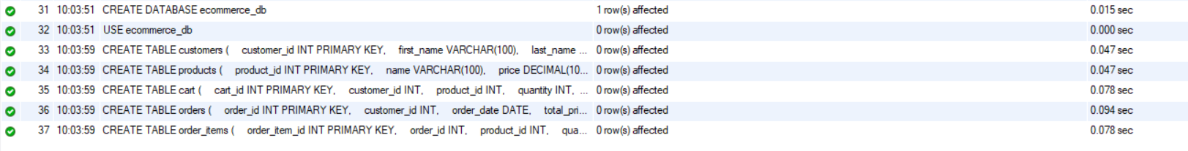

**Inserting values**

Product Table

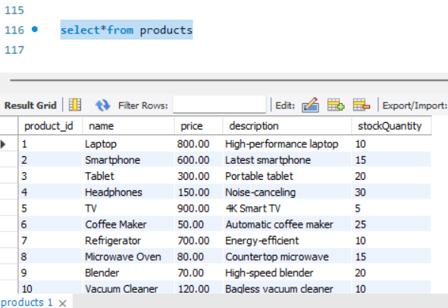

Customers Table

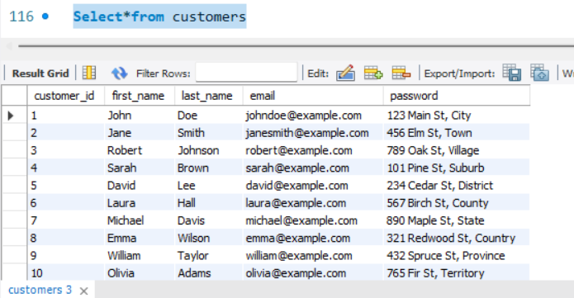

Orders table

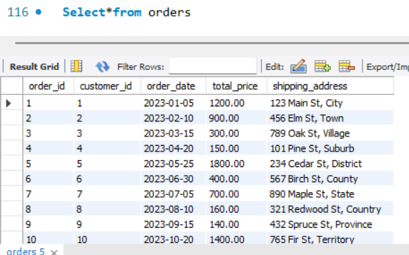

Orders Items Table

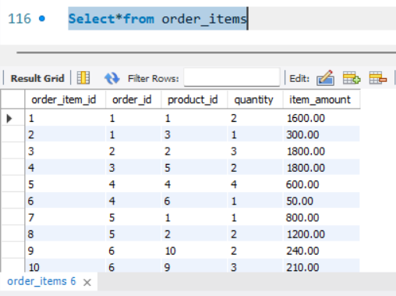

Cart table

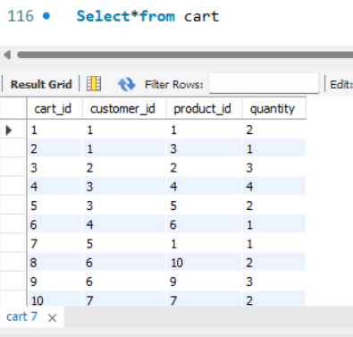

# SQL Queries for Given Questions

1. Update refrigerator product price to 800.

UPDATE products SET price = 800.00 WHERE name = 'Refrigerator';

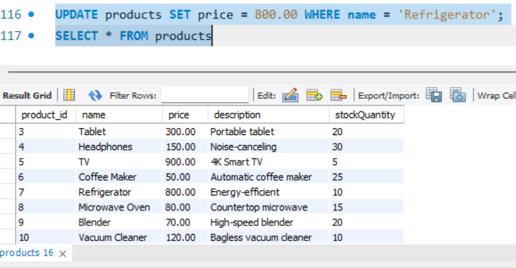

2. Remove all cart items for a specific customer (e.g., customer_id = 3).

DELETE FROM cart WHERE customer_id = 3;

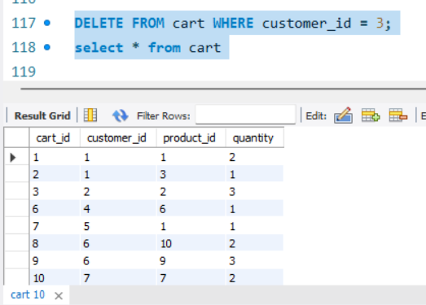

3. Retrieve Products Priced Below $100.

SELECT * FROM products WHERE price < 100.00;

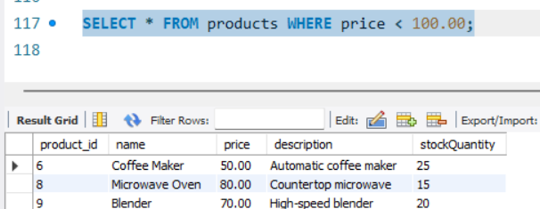

4. Find Products with Stock Quantity Greater Than 5.

SELECT * FROM products WHERE stockQuantity > 5;

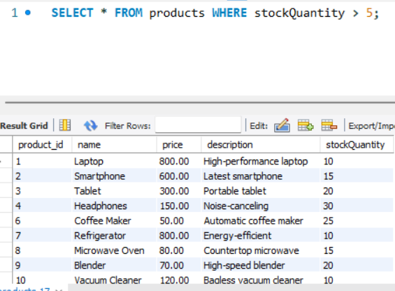

5. Retrieve Orders with Total Amount Between $500 and $1000.

SELECT * FROM orders WHERE total_price BETWEEN 500 AND 1000;

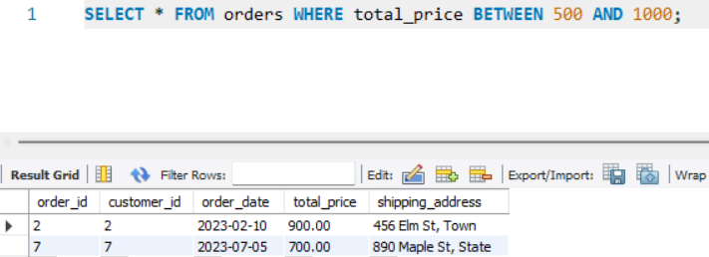

6. Find Products which name end with letter ‘r’.

SELECT * FROM products WHERE name LIKE '%r';

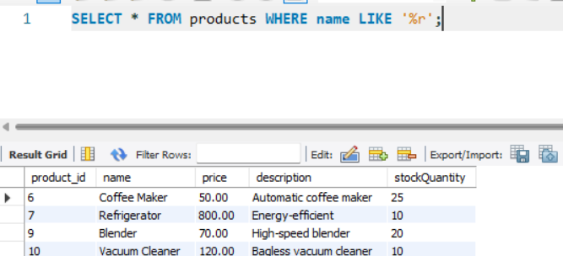

7. Retrieve Cart Items for Customer 5.

SELECT * FROM cart WHERE customer_id = 5;

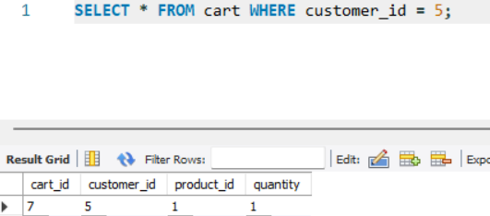

8. Find Customers Who Placed Orders in 2023.

SELECT DISTINCT c.* FROM customers c JOIN orders o ON c.customer_id = o.customer_id WHERE YEAR(order_date) = 2023;

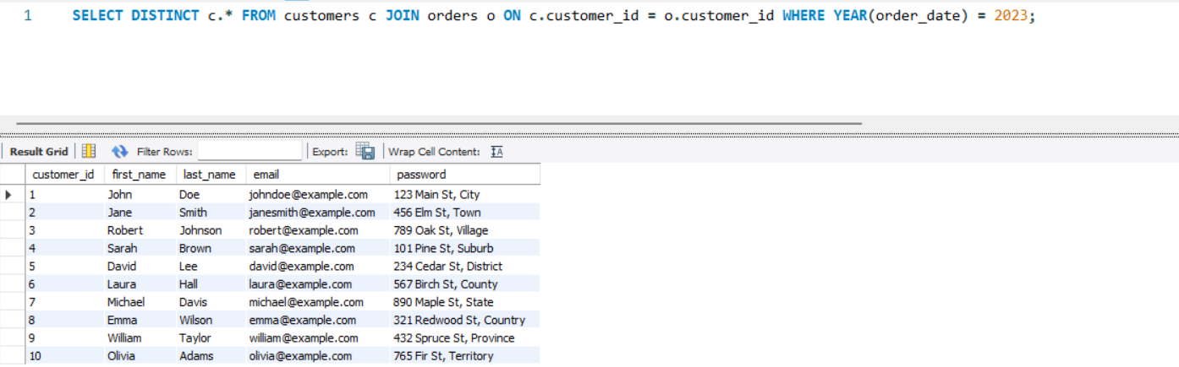

9. Determine the Minimum Stock Quantity for Each Product .

SELECT MIN(stockQuantity) AS MinStock FROM products;

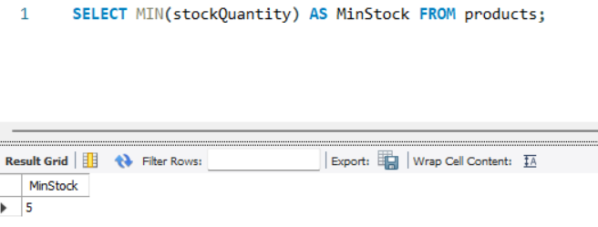

10. Calculate the Total Amount Spent by Each Customer.

SELECT customer_id, SUM(total_price) AS total_spent FROM orders GROUP BY customer_id;

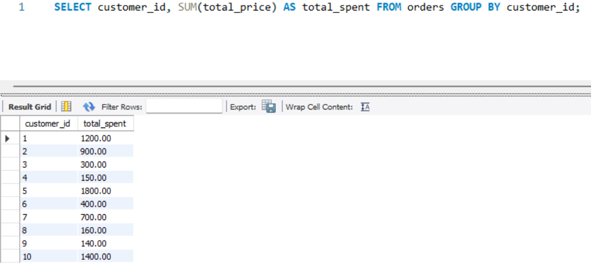

11. Find the Average Order Amount for Each Customer.

SELECT customer_id, AVG(total_price) AS avg_order_amount FROM orders GROUP BY customer_id;

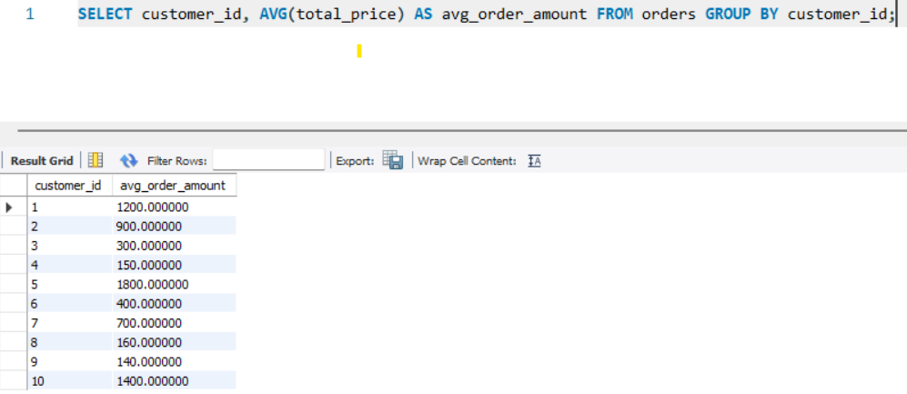

12. Count the Number of Orders Placed by Each Customer.

SELECT customer_id, COUNT(order_id) AS order_count FROM orders GROUP BY customer_id;

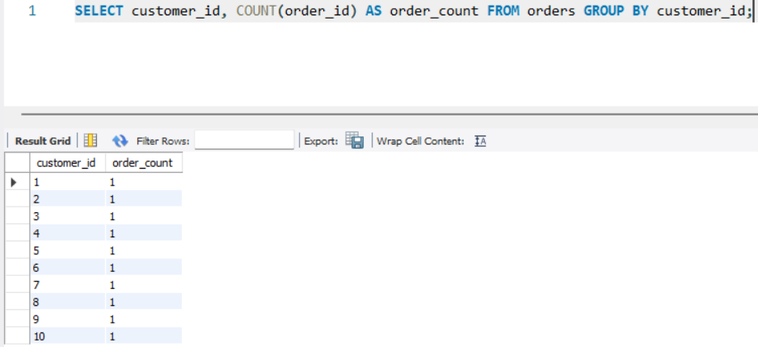

13. Find the Maximum Order Amount for Each Customer.

SELECT customer_id, MAX(total_price) AS max_order_amount FROM orders GROUP BY customer_id;

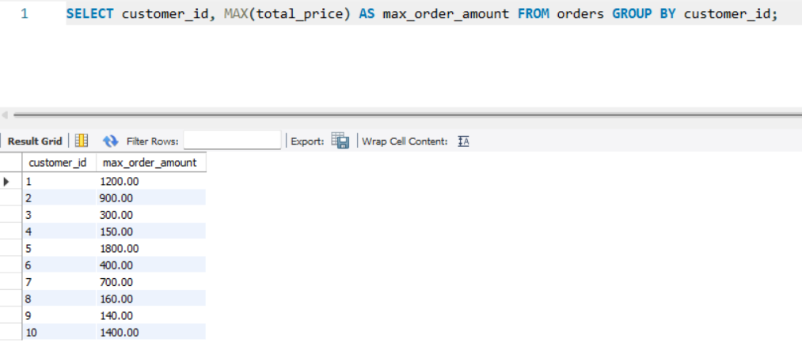

14. Get Customers Who Placed Orders Totaling Over $1000.

SELECT customer_id FROM orders GROUP BY customer_id HAVING SUM(total_price) > 1000;

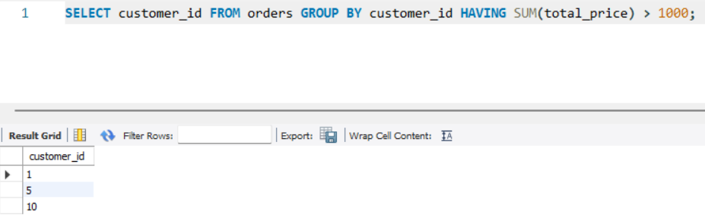

15. Subquery to Find Products Not in the Cart.

SELECT * FROM products WHERE product_id NOT IN (SELECT product_id FROM cart);

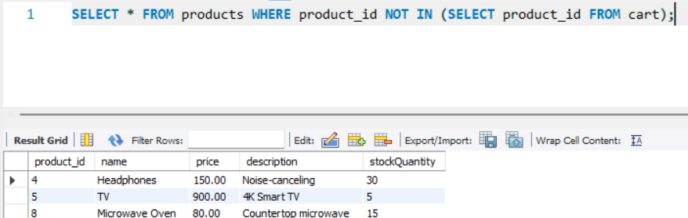

16. Subquery to Find Customers Who Haven't Placed Orders.

SELECT * FROM customers WHERE customer_id NOT IN (SELECT DISTINCT customer_id FROM orders);

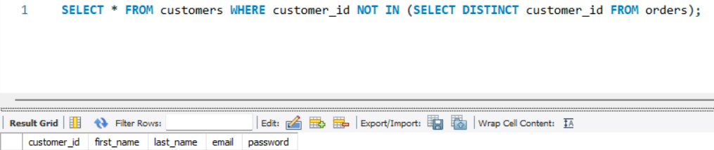

17. Subquery to Calculate the Percentage of Total Revenue for a Product .

SELECT product_id,   
ROUND(SUM(item_amount) * 100 / (SELECT SUM(item_amount) FROM order_items), 2) AS revenue_percentage   
FROM order_items   
WHERE product_id = 1   
GROUP BY product_id;

Only for the particular product (product id=1)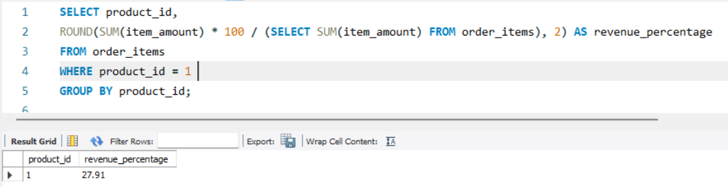

Example : Using Max() to get the total revenue of the product

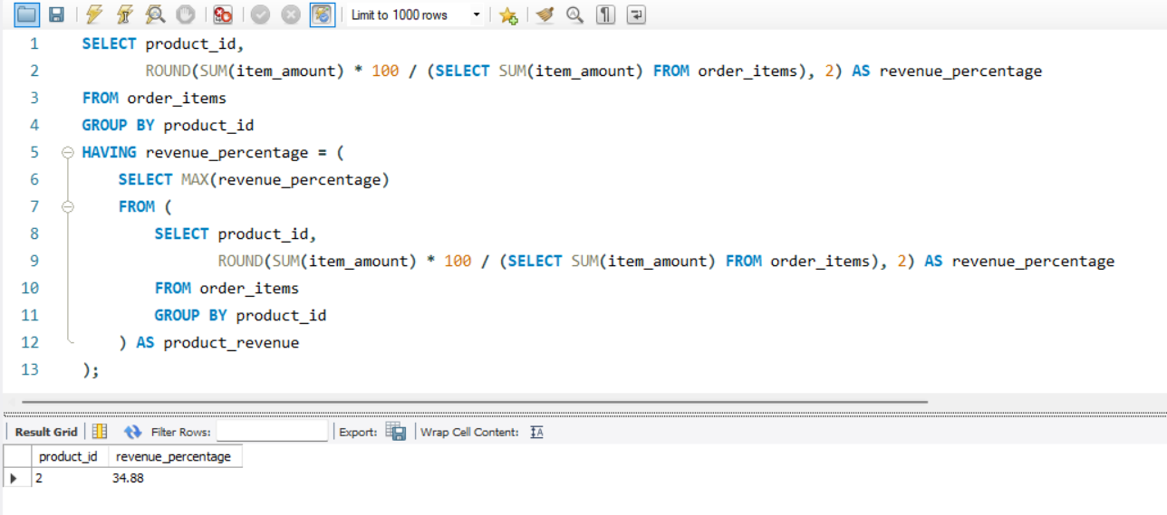

18. Subquery to Find Products with Low Stock .

SELECT * FROM products WHERE stockQuantity < (SELECT AVG(stockQuantity) FROM products);

Using Avg() to find product with low stock

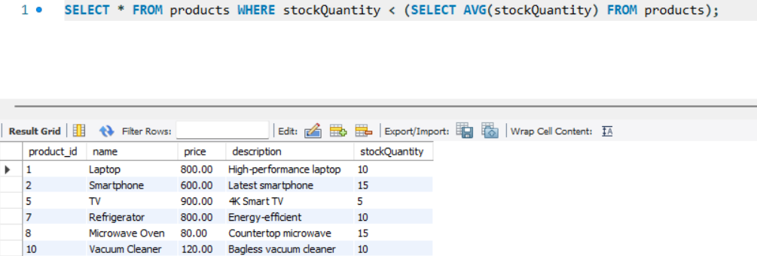

Example : Subquery – Products with Stock Below a Threshold (e.g., < 10)

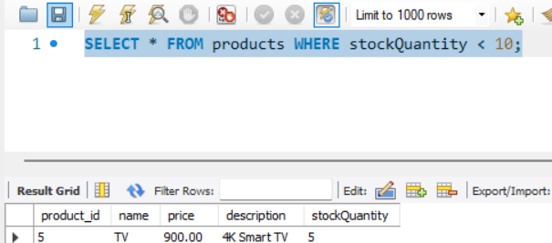

19. Subquery to Find Customers Who Placed High-Value Orders.

SELECT * FROM customers WHERE customer_id IN (

SELECT customer_id

FROM orders

WHERE total_price = (

SELECT MAX(total_price) FROM orders

));

Using max() function to find the High-Value Orders

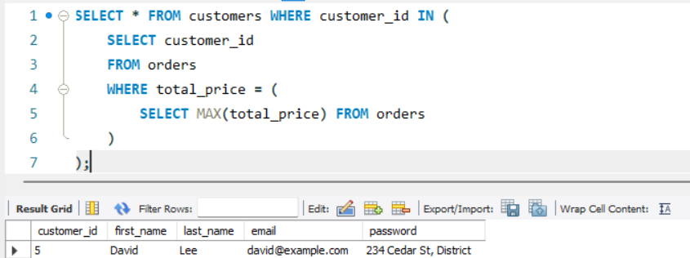

Example : For customers greater than 1000 (high value order)

